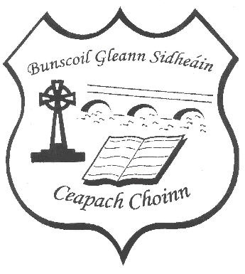**Bunscoil Gleann Sidheáin/Cappoquin Primary School**

**Annual Admission Notice**

**Roll No 20157V**

**Annual Admission Notice 01/10/2024**

**In respect of admissions to the 2025/26 school year**

**ADMISSION POLICY AND APPLICATION FORM**

A copy of the school’s **Admission Policy** and the **Application Form for Admission** for 2025/26 is available as follows:

To download at:[**www.cappoquinschool.com**](http://www.cappoquinschool.com)

On request by emailing[**cappoquinschool@gmail.com**](mailto:cappoquinschool@gmail.com)or writing to

Bunscoil Gleann Sidheáin/Cappoquin Prinmary School, Shanbally, Cappoquin, Co Waterford. P51E732.

**PART 1 – Admissions to the 2025/26 school year.**

**Application and Decision Dates for admission to the 2025/26 school year** The following are the dates applicable for admission to junior infants:

|  |  |
| --- | --- |
| The school will commence accepting applications for admission on | **6th January 2025** |
| The school shall cease accepting applications for admission on | **31st January 2025** |
| The date by which applicants will be notified of the decision on their application is | **On or before 21st February 2025** |
| The period within which applicants must confirm acceptance of an offer of admission is**\*** | **2 weeks** |

**\*Failure to accept an offer within the prescribed period above may result in the offer being withdrawn.**

**Note: the school will consider and issue decisions on late applications in accordance with the school’s Admission Policy.**

# Special Class Application and Decision Dates for admission to the 2025/26 school year

The following are the dates applicable for admission to the school’s special class which caters for children with Autistic Spectrum Disorders:

|  |  |
| --- | --- |
| The school will commence accepting applications for admission to the special class on | **6th January 2025** |
| The school shall cease accepting applications for admission to the special class on | **31st January 2025** |
| The date by which applicants will be notified of the decision on their application for admission to the special class is | **On or before 21st February 2025** |
| The period within which applicants must confirm acceptance of an offer of admission to the special class is**\*** | **2 weeks** |

\***Failure to accept an offer within the prescribed period above may result in the offer being withdrawn.**

# Number of places being made available in the 2025/26 school year

|  |  |
| --- | --- |
| The number of available places in junior infants. | **28** |
| The number of residential places is (boarding schools only) | **N/A** |
| The number of non-residential places is (boarding schools only) | **N/A** |
| The number of places being made available in the special class catering for children with Autistic Spectrum Disorders. | **1** |