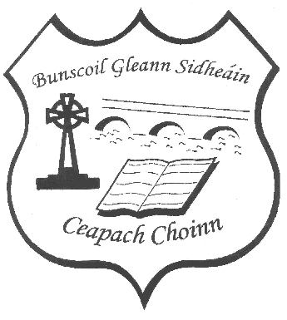
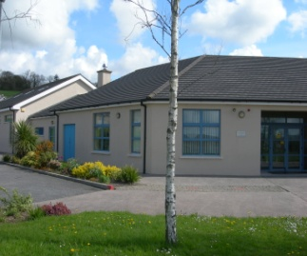
Stay Safe Policy
Review January 2024

Policy on the Stay Safe Programme
Buscoil Gleann Sidheáin teaches the Stay Safe Programme, a teaching package designed for use in Irish primary schools. It was researched and developed by the Child Abuse Prevention Programme. The principal aim of the programme is to prevent both physical and sexual abuse of children.

Under Child Protection Guidelines all schools are obliged to teach the Stay Safe programme. The Stay Safe Programme was updated in 2016 and since the 2017/2018 school year onwards the new Stay Safe Programme is implemented in the school.

Stay Safe is taught as part of the SPHE (Social Personal and Health Education) curriculum and it will be taught in the second term each year. Children from Junior infants to sixth class participate in formal lessons on the Stay Safe Programme.

Parents/Guardians are encouraged to become involved by discussing each lesson with their child and helping their child to complete each worksheet based on the lessons in the programme.
It is considered good practice to inform parents in advance of commencement that the Stay Safe Programme is due to be taught and to direct them to www.pdst.ie/staysafe to see the content of the lessons and for any further information.

In the event that a parent informs the school that they wish to withdraw their child from the Stay Safe Programme, a written record of their reasons for doing is required from the parent. This is retained on the child’s school file.

Staff will be facilitated to attend CPD training in the Stay Safe programme.

Roles and Responsibilities
The Principal, Deputy Principal and two APII teachers (overseen by the BOM) are responsible for overseeing and supporting the implementation of the Stay Safe aspect of the S.P.H.E. Programme.

Class teachers are responsible for the implementation of Stay Safe Programme in their classes, including the distribution of relevant information and notes to parents/carers.

Communication
This policy will be published on the school website. Hard copies of this, and all school policies, are available at the school upon request.

Review and Ratification
The plan/policy will be reviewed by the entire staff and Board of Management every three years. The next review will take place during the school year of 2026/2027.

This policy was reviewed and adopted by the Board of Management of Bunscoil Gleann Sidheáin, Cappoquin, Co, Waterford on ____________________________________

Signed: Signed:

___________________________ ___________________________
Keith Dransfied Martin Delaney
(Chairperson of Board of Management) ( Principal)
Date: ____________ Date: ____________

Appendix 1: Stay Safe Key Vocabulary
Topic 1: Feeling Safe and Unsafe
Infants | 1st/2nd | 3rd/4th | 5th/6th
Excited  Happy  Scared  Upset  Sad  Angry | Frightened  Pleased  Annoyed  Hurt  Sorry  Calm | Comfortable  Embarrassed  Enthusiastic  Foolish  Guilty  Worried  Jealous  Frustrated  Cheerful  Stupid | Pity  Empathy  Sympathy  Lonely  Depressed  Confused  Exhilarated  Impatient  Excluded  Delighted

Topic 2: Friendship and Bullying
Infants | 1st/2nd | 3rd/4th | 5th/6th
Friend(ship)  Sharing  Thoughtful  Listening  Helping  Taking turns  Being fair  Bullying  On purpose  Hurts  Frightens  More than once  Co-operating  Put-downs | Respect  Interview  Cyberbullying  On purpose  Deliberately  Exclude  Include  Ignore  Threaten  Rumour agreement | Courtesy  Honest  Loyal  Unacceptable  Outcome  Physical  Verbal  Emotional  Identity  Mimicking  Racism  Disability  Homophobic  Ethnic  Nationality  Observance  Country of origin  Gender  Lesbian  Gay | Resolve  Pathetic  Offensive  Viral  Body language  Assertive  Tolerate

Topic 3: Touches
Infants | 1st/2nd | 3rd/4th | 5th/6th
Private  Public  Personal  Penis  Vagina  Breast  Confusing  Senses – see, hear, smell, touch, taste secret | Facial expression  Body language  Embarrassed  Trust | Ungrateful | Sympathy  Assertive  Dilemma  Convince  Opponent  Strategy

Topic 4: Secrets and Telling

Infants | 1st/2nd | 3rd/4th | 5th/6th
Surprise  Uncomfortable  Unsure Bribe  Threat | Pranks  Blamed  Dare By accident responsible |  | Testicles Uncomplicated

Topic 5: Strangers

Infants | 1st/2nd | 3rd/4th | 5th/6th
Stranger  Rules  Say no  Get away  Tell | Comments  Behave  Option  Directions  Nasty | Steward | Appropriately  Wary

