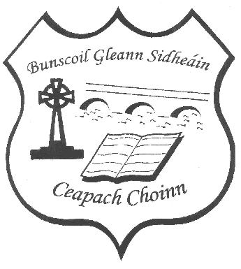Bunscoil Gleann Sidheáin/Cappoquin Primary School

Annual Admission Notice

Roll No 20157V

Annual Admission Notice 01/10/2025
In respect of admissions to the 2026/27 school year

ADMISSION POLICY AND APPLICATION FORM
A copy of the school’s Admission Policy and the Application Form for Admission for 2026/27 is available as follows:
To download at: www.cappoquinschool.com
On request by emailing cappoquinschool@gmail.com or writing to
Bunscoil Gleann Sidheáin/Cappoquin Prinmary School, Shanbally, Cappoquin, Co Waterford. P51E732.

PART 1 – Admissions to the 2026/27 school year.
Application and Decision Dates for admission to the 2025/26 school year The following are the dates applicable for admission to junior infants:
The school will commence accepting applications for admission on | 5th January 2025
The school shall cease accepting applications for admission on | 30th January 2025
The date by which applicants will be notified of the decision on their application is | On or before 21st February 2025
The period within which applicants must confirm acceptance of an offer of admission is* | 2 weeks
*Failure to accept an offer within the prescribed period above may result in the offer being withdrawn.
Note: the school will consider and issue decisions on late applications in accordance with the school’s Admission Policy.

Special Class Application and Decision Dates for admission to the 2025/26 school year
The following are the dates applicable for admission to the school’s special class which caters for children with Autistic Spectrum Disorders:
The school will commence accepting applications for admission to the special class on | 5th January 2025
The school shall cease accepting applications for admission to the special class on | 30th January 2025
The date by which applicants will be notified of the decision on their application for admission to the special class is | On or before 21st February 2025
The period within which applicants must confirm acceptance of an offer of admission to the special class is* | 2 weeks
*Failure to accept an offer within the prescribed period above may result in the offer being withdrawn.

Number of places being made available in the 2025/26 school year
The number of available places in junior infants. | 28
The number of residential places is (boarding schools only) | N/A
The number of non-residential places is (boarding schools only) | N/A
The number of places being made available in the special class catering for children with Autistic Spectrum Disorders. | 1

